1. Team Structure (4 Members – Full-Stack Oriented)
👤 Team Member 1 – Full-Stack Lead (Auth & Core Platform)
- Identity & Access Management (Backend + UI)
- Authentication, RBAC, audit logs
- Login, role-based routing, security integration
👤 Team Member 2 – Full-Stack Engineer (Programs & Participation)
- Wellness Program & Activity Management (API + UI)
- Employee participation & goal tracking
- Program creation screens, activity flows
👤 Team Member 3 – Full-Stack Engineer (Engagement & Compliance)
- Feedback & engagement modules
- Compliance & policy management
- Compliance dashboards, audit workflows
👤 Team Member 4 – Full-Stack + DevOps & Quality
- Notifications & alerts (backend + frontend)
- CI/CD, deployment, environment setup
- Testing, performance, security validation

2. Tech Stack (Recommended)
Layer | Technology
Frontend | Angular+ TypeScript + Material UI
Backend | Spring Boot (Java 17)
Auth | JWT + Spring Security
Database | Mysql
API Gateway | Spring Cloud Gateway / NGINX
Build | Maven / Gradle
CI/CD | GitHub Actions
Deployment | Docker + Kubernetes (optional)

3.1 Core Design Diagrams
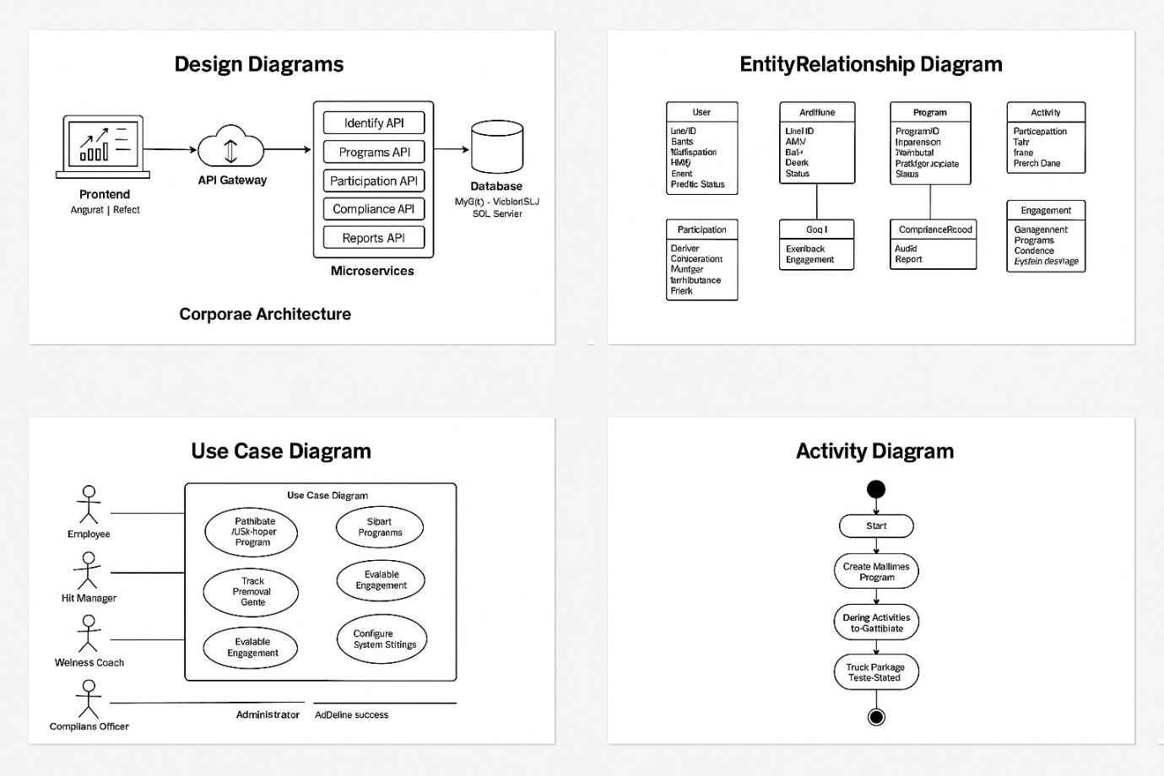

4. Repository Structure
welltrack/
├── backend/
│ ├── auth-service/
│ ├── program-service/
│ ├── participation-service/
│ ├── compliance-service/
│ ├── reporting-service/
│ └── notification-service/
│
├── frontend/
│ ├── employee-portal/
│ ├── hr-dashboard/
│ └── admin-panel/
│
├── database/
│ ├── schema.sql
│ └── seed-data.sql
│
├── docker-compose.yml
└── README.md

5. Database Schema (Core Tables Example)
CREATE TABLE User (
UserID SERIAL PRIMARY KEY,
Name VARCHAR(100),
Role VARCHAR(30),
Email VARCHAR(100) UNIQUE,
Phone VARCHAR(15),
Status VARCHAR(20)
);

CREATE TABLE Program (
ProgramID SERIAL PRIMARY KEY,
Title VARCHAR(150),
Description TEXT,
HRID INT REFERENCES User(UserID),
StartDate DATE,
EndDate DATE,
Status VARCHAR(20)
);

CREATE TABLE Activity (
ActivityID SERIAL PRIMARY KEY,
ProgramID INT REFERENCES Program(ProgramID),
Title VARCHAR(150),
Type VARCHAR(30),
Date DATE,
Duration INT,
Status VARCHAR(20)
);

6. Core API Design (Sample)
🔐 Auth Service
- POST /auth/login
- POST /auth/register
- GET /users
🧘 Program Service
- POST /programs
- GET /programs
- POST /activities
- GET /activities/{programId}
🏃 Participation Service
- POST /participation/join
- GET /participation/employee/{id}
- POST /goals
✅ Compliance Service
- POST /compliance/audit
- GET /compliance/program/{id}
📊 Reporting Service
- GET /reports/engagement
- GET /reports/compliance
🔔 Notification Service
- POST /notifications
- GET /notifications/user/{id}

7. Frontend Module Mapping
Employee Portal
- Program catalog
- Join activities
- Goals tracking
- Feedback submission
HR Dashboard
- Create/Edit programs
- Participation metrics
- Engagement analytics
Coach Console
- Schedule activities
- Attendance control
Compliance Workbench
- Policy audits
- Compliance records

8. Plan
Foundation
- Repo setup
- DB schema
- Auth & RBAC
Programs & Activities
- Program CRUD
- Activity scheduling
- UI layouts
Participation & Goals
- Participation flow
- Goal tracking
- Employee UI
Engagement & Feedback
- Feedback APIs
- Engagement scoring
Compliance & Reporting
- Audit trails
- Reports dashboards
Notifications, Testing & Deployment
- Alerts
- CI/CD
- Final demo

9. Security & NFR Implementation
- JWT-based authentication
- Role-based API guards
- HTTPS + encrypted DB
- Immutable audit logs
- Load testing (10k users)
- 99.9% availability via container replicas

10. Deployment (Local → Prod)
docker-compose up
Services:
- frontend
- api-gateway
- auth
- program
- participation
- compliance
- reporting
- notification
- mysql

11. Final Deliverables
✅ Working web application ✅ REST APIs ✅ Role-based dashboards ✅ Compliance-ready audit logs ✅ Reports & metrics ✅ Deployment scripts

